**SCTR’s Pune Institute of Computer Technology Dhankawadi, Pune**

**A.Y. 2022-23**

**WADL MINI PROJECT REPORT ON**

**“Entrance Exam Form Portal”**

**Submitted By**

ROLL NUMBER

33120

33135

33171

**Under the guidance of**

Mrs. Rachna Karnawat



**DEPARTMENT OF INFORMATION TECHNOLOGY**

**ACADEMIC YEAR 2022-23**

1

**ABSTRACT**

An entrance exam form portal is an online platform that simplifies the application process for students who want to apply for entrance exams to various universities, colleges, and institutions. The portal provides a user-friendly interface that allows students to register, select the entrance exam, and fill in the online application form. It also offers various online payment options to facilitate the payment of application fees and generates an admit card for eligible candidates. The portal also provides transparency in the admission process by displaying the merit list and cut-off marks for each entrance exam. The development of an entrance exam form portal can automate the application process, reduce errors and delays, and provide convenience and efficiency to the students, institutions, and the admission process.

2

**INTRODUCTION**

The process of applying for entrance exams to various universities, colleges, and institutions has traditionally been a time-consuming and cumbersome task. Students have to visit the institutions to obtain and submit application forms, stand in long queues, and pay application fees through manual methods. Additionally, the manual process does not provide transparency, as students are unaware of the merit list and cut-off marks for the entrance exams. Therefore, there is a need for an efficient and user-friendly entrance exam form portal that can simplify the application process, save time, and provide transparency in the admission process.

An entrance exam form portal is an online platform that simplifies the application process for students who want to apply for entrance exams to various universities, colleges, and institutions. The portal provides a user-friendly interface that allows students to register, select the entrance exam, and fill in the online application form. It also offers various online payment options to facilitate the payment of application fees and generates an admit card for eligible candidates. The portal also provides transparency in the admission process by displaying the merit list and cut-off marks for each entrance exam.

3

**LITERATURE SURVEY**

Literature survey for the topic "Entrance Exam Form Portal" reveals that various studies and research have been conducted to understand the benefits of using online portals for the application process.

1. A study conducted by Singh and Kumar (2016) highlights the importance of online portals for the admission process in Indian universities. The study found that the use of online portals can streamline the admission process, reduce the workload of the admission staff, and provide transparency in the admission process.
2. A study conducted by Sengupta and Chakraborty (2018) focuses on the implementation of an online admission system in higher education institutions in India. The study found that the implementation of an online admission system can improve the efficiency of the admission process, reduce errors and delays, and provide convenience to the students.
3. A study conducted by Ahmed and Rahman (2019) evaluates the effectiveness of online admission systems in Bangladesh. The study found that the use of online admission systems can improve the quality of the admission process, reduce the workload of the admission staff, and provide convenience to the students.

4

1. A study conducted by Alharbi (2019) focuses on the development of an online admission system for Saudi Arabian universities. The study found that the implementation of an online admission system can improve the efficiency of the admission process, reduce errors and delays, and provide transparency in the admission process.
2. A study conducted by Ahmed and Khan (2020) evaluates the effectiveness of an online admission system in Pakistani universities. The study found that the use of an online admission system can improve the efficiency of the admission process, reduce the workload of the admission staff, and provide convenience to the students.

5

**IMPLEMENTATION DETAILS**

Web technologies used: In the mini project we used the following web technologies:

* Node.js
* React.js
* Express.js
* MongoDB

Frontend development: React.js web technology was used for developing the front end of the website.

Backend development: Node.js and Express.js was used for developing the backend of the website.

Integration: Express.js web technology was used for integration part of the website.

6

**OUTPUT**

7

8

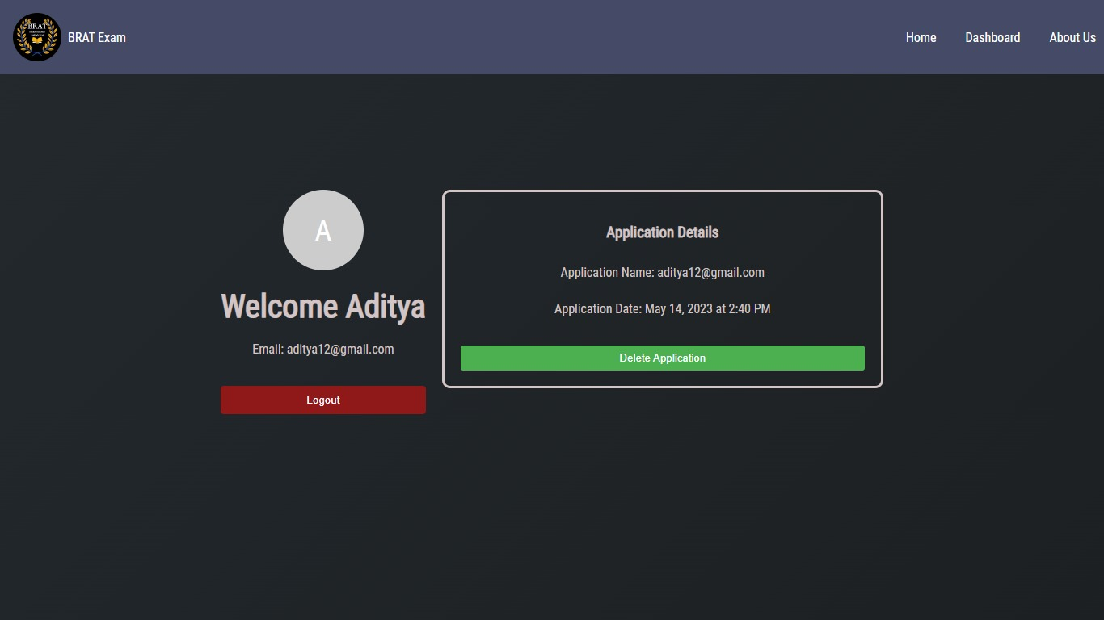

**9**

**10**

**CONCLUSION**

In conclusion, an entrance exam form portal is an online platform that simplifies the application process for students who want to apply for entrance exams to various universities, colleges, and institutions. The development of an entrance exam form portal can automate the application process, reduce errors and delays, and provide convenience and transparency to the students, institutions, and the admission process as a whole. The literature survey reveals that the use of online portals for the admission process can bring significant benefits to the students and institutions. The implementation of an entrance exam form portal can streamline the application process, reduce errors and delays, and provide convenience and transparency to the students. It can also reduce the workload of the admission staff, increase the reach of educational institutions, and improve the efficiency and quality of the admission process. Therefore, the development of an entrance exam form portal is essential to ensure an efficient and user-friendly admission process for students and institutions.

9

**REFERENCES**

**1.** [**https://youtu.be/YhJ-lPiCfyc**](https://youtu.be/YhJ-lPiCfyc)

**2.** <https://www.w3schools.com/>

**3.** <https://www.mongodb.com/docs/>

**4.** <https://nodejs.org/en/docs>

**5.** <https://www.w3schools.com/react/>

**6.** <https://expressjs.com/en/5x/api.html>

10